SYNOPSIS

EMPLOYEE SALARY PREDICTION USING REGRESSION MODELS

PROBLEM ID: 3

STUDENT NAME - SURYANSH
UNIVERSITY ROLL NUMBER - 2028873
SECTION - L G2

STUDENT NAME – PRATEEK BUGANA
UNIVERSITY ROLL NUMBER - 2028804
SECTION - L G2
STUDENT NAME – AYUSHMAN SHARMA
UNIVERSITY ROLL NUMBER - 2028687
SECTION - L G2
STUDENT NAME – KANAV RASTOGI
UNIVERSITY ROLL NUMBER - 2028735
SECTION - L G2

PROBLEM DESCRIPTION:
- This project is about creating a system that uses machine learning to guess employee salaries. The system uses a set of data that is made to look like it comes from a real company. This data has lots of information about each employee like how old they're how long they have been working and what kind of job they do.
- The data has twenty things that describe each employee including numbers like age and years of experience and categories like what kind of education they have and what department they work in. The thing we are trying to guess is the employees salary.
- First we look at the data to see what it looks like. If there are any patterns. We do this to understand the data better. Then we clean up the data by fixing any mistakes and making sure everything is, in the format. We also pick the important things that help us guess the salary.
- We try out three ways of guessing the salary: Linear Regression, Ridge Regression and Lasso Regression. We compare these methods to see which one is best. We use measurements to see how good each method is.
- The goal of the project is to show how to use machine learning to guess salaries in a way that's fair and accurate. We want to make sure we do everything right from getting the data ready to picking the method so we can guess salaries correctly. The employee salaries are what we are trying to predict. We use the machine learning system to do this.

STEPS OF IMPLEMENTATION:

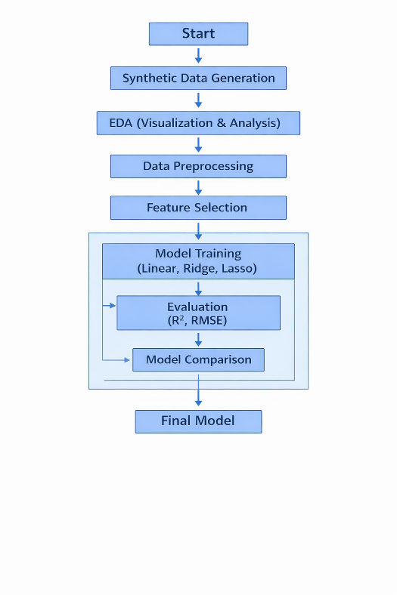

1. SYNTHETIC DATA GENERATION
- Create a dataset with 20 employee-related features like age, experience, and job role.
- Simulate real-world organizational data using random values.
- Define salary as the target variable based on feature relationships.

2. EXPLORATORY DATA ANALYSIS (EDA)
- Analyze data distribution using histograms and plots.
- Identify relationships between features and salary.
- Detect outliers and patterns in the dataset.

3. DATA PREPROCESSING
- Handle missing values and remove inconsistencies.
- Convert categorical data into numerical form using encoding.
- Normalize or scale numerical features for better model performance.

4. FEATURE SELECTION (FORWARD SELECTION)
- Select the most important features that influence salary.
- Add features step-by-step based on model performance.
- Reduce irrelevant features to improve accuracy and efficiency.
5. MODEL TRAINING (LINEAR, RIDGE, LASSO)
- Train Linear Regression model to establish baseline performance.
- Apply Ridge Regression to handle multicollinearity.
- Use Lasso Regression for feature selection and regularization.
6. TRAINING AND VALIDATION
- Split dataset into training and testing sets.

EXPECTED MODULES/ LIBRARIES TO BE USED :
- NumPy – used for numerical computations
- Pandas – used for data manipulation and dataset handling
- Matplotlib – used for basic data visualization
- Seaborn – used for advanced visualization like heatmaps
- Scikit-learn – used for ML models, preprocessing, and evaluation
- Statsmodels – optional, for statistical analysis

EXPECTED EVALUATION METRICS AND PLOTS TO BE USED:
- R² Score – to measure model accuracy
- RMSE – to measure prediction error
- Correlation Heatmap – to understand feature relationships
- Histogram – to check data distribution
- Scatter Plots – to analyze feature vs salary relationship
- Residual Plot – to evaluate model performance

REQUIRED TOPICS FROM SUBJECT
Machine Learning Basics
- It is a method where computers learn patterns from data.
- Helps in making predictions like employee salary.
- Does not require explicit programming for every task.
Linear Regression
- Used to predict continuous values like salary.
- Finds a straight-line relationship between input and output.
- Simple and commonly used as a base model.
Data Preprocessing
- Involves cleaning data and handling missing values.
- Converts categorical data into numerical form.
- Improves model accuracy by scaling features.
Model Evaluation (R² & RMSE)
- R² score shows how well the model fits the data.
- RMSE measures prediction error.
- Helps compare and select the best model.

PLATFORM REQUIRED:
- Jupyter Notebook: It provides us an interactive environment that allows writing and executing code in cells.
BOOKS AND LINK SOURCES:
- Hands-On Machine Learning by Aurélien Géron
- Pattern Recognition and Machine Learning by Bishop
- Scikit-learn Official Documentation
- Kaggle & Towards Data Science

